**Containerize the app**

|  |  |
| --- | --- |
| Date | 19 November 2022 |
| Team ID | PNT2022TMID12566 |
| Project Name | News Tracker Application |

**Docker file:**

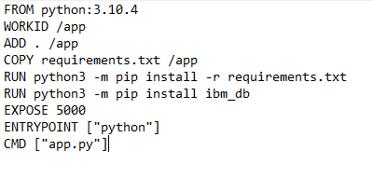

**Building Image:**

docker build -t <image_name> .

Execute the above command in the working directory where Dockerfile is present.

**Run the container:**

Docker run -d -p <port>:<port><image_name>

Execute the command to run the container in the mentioned port number.

Open localhost:5000 or 127.0.0.1:5000 to view the running container.

